CONFIDENTIAL

Discrimination Email/Text Service Procedure

Procedure
This procedure explains Harrogate Town AFC’s Discrimination Reporting Email/Text service and how to deal with incidents in which it is reported and evidencing of any incidents which are reported.

If any Fans feel they have been discriminated against by the organisation or the public, there are a number of ways they can report. The email/text service is widely promoted throughout HTAFC’s stadium.

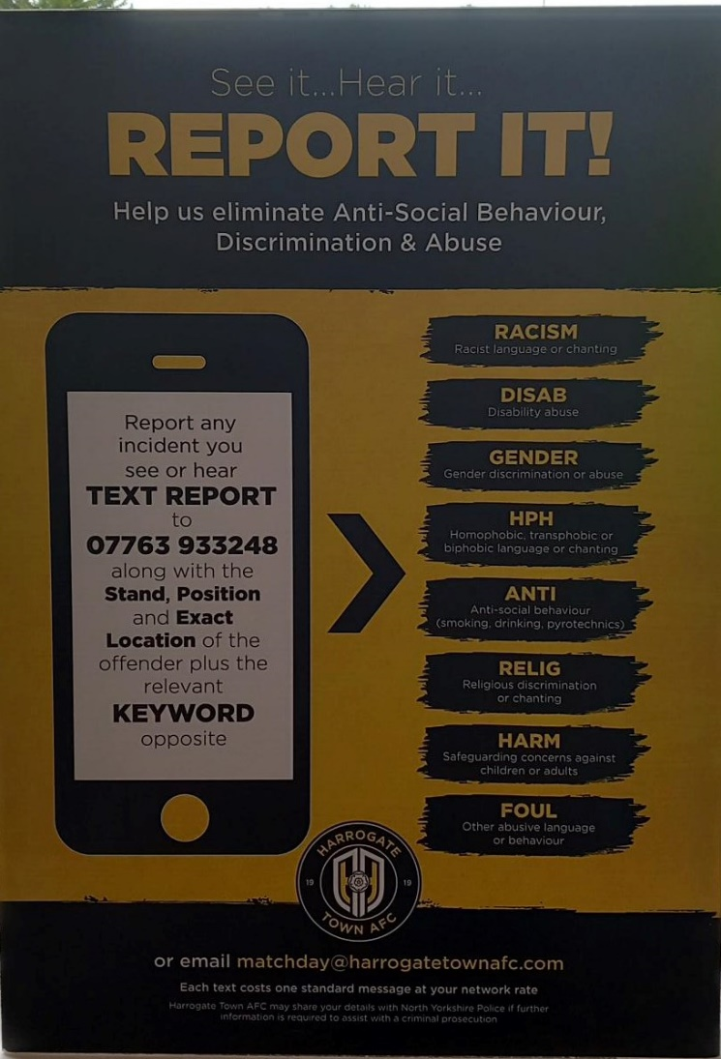

During a Match

The email/text service(s) edi@harrogatetownafc.com and matchday@harrogatetownafc.com will be linked directly to information received in the match control room and accessed either by a member of the Safety team, Safeguarding Officer, or the ED&I Manager.

The incident will first be brought to the attention of HTAFC’s Safety Officer.

The Police and Safety Officer should seek to identify the person/people responsible and take appropriate action while the match continues.

If, after a reasonable amount of time, the problem continues then the Referee, in consultation with the Police and Safety Officer, may remove the players from the field of play and suspend the match, allowing the Police and Safety Officer a further opportunity to deal with the problem.

- Only if the matter cannot be dealt with satisfactorily, warnings having gone unheeded and the welfare of any of the participants, in terms of facing the threat of continued racist, homophobic, or other abuse, remains at risk, should the Referee consider abandoning the match.

- Any decision to suspend or abandon a match should be taken by the Referee after full consultation with the Police, Safety Officer and where possible with the EFL Football Services Department or Duty Director.
- Where no Police are present in the stadium then the initial decision-making responsibility falls on the Safety Officer, including informing the Police.

- After the game HTAFC will take the time to email the reporting individual to thank them for the report and provide information of the action which was taken.

- HTAFC will input the incident within the discrimination incident log.

After the Match

The email/text service(s) edi@harrogatetownafc.com and matchday@harrogatetownafc.com will be monitored by a member of Harrogate Town AFC either the Safeguarding Officer or the ED&I Manager.

The incident should be inputted within the discrimination incident log.

The incident will be reported and brough to the attention of the HTAFC’s Safety Officer.

- The Safety Officer will investigate the incident and utilise CCTV to identify any potential culprit.

- The incident will be included within any future Match Day briefing.

- HTAFC will take the time to email the reporting individual to thank them for the report and provide information of the action which was taken.

How Will You Tell Me About Changes to This Privacy Notice?
We keep our Discrimination Reporting Email/Text service under regular review. Any changes we make in the future will be posted on this page.

Changes to this procedure
This policy/procedure may be amended and reissued at any time.

